PROJECT REPORT

ON

“CAR RENTAL DATABASE MANAGEMENT SYSTEM”

Course: INFO 6210 Database Management and Database Design

Spring 2018

Prof. Yusuf Ozbek

Submitted By: Rutvik Bhopatrao

NUID: 001824489



Contents

|  |  |  |
| --- | --- | --- |
| 1 | Introduction | 3 |
| 2 | Business Rules | 3 |
| 3 | Entities | 4 |
| 4 | Assumption | 4 |
| 5 | EER Diagram | 5 |
| 6 | PL/SQL Statement | 6 |
| 7 | Conclusion | 11 |
| 8 | SQL Dump Statements | 12 |

Introduction:

The project involves creating a database for a Car Rental system. In this database, Customer can rent a car based on make and a model. The database provides customer choice to have different pick-up and drop-off locations and will impose late fee if the rental car is returned beyond the return date and time. The Customers can purchase car rental insurance which is optional and can use up to one discount coupon to their final bill. The detailed description is given further.

Business Rules:

1. Car rental agency has collection of locations and variety of cars at each location.
2. Customer creates an account and that customer needs to be the driver of the car.
3. Each car should belong to a Car type and each car will belong to a location.
4. Customer, based on his location and car category preferences, rents a car.
5. Based on his location and car category preferences, list of cars available to rent will be shown along with available date and time (from and to).
6. Customer will select a car from the suggestions and should be able to reserve it for rent.
7. When a customer reserves a car, he/she should be able to optionally purchase a Car Insurance Plan and should be able to apply at most one discount code.
8. Billing is generated when a car is returned.
9. Customer can return the car before the due date, on the due date or he/she can return it late.
10. If a customer returns a car after the due date, additional late fee is calculated and added to the bill.
11. A default 8.25% tax is applied on the amount which also includes the late fee and this tax is added to obtain the total amount to which the discount will be applied, and a final amount is obtained.
12. Once the car is returned it becomes available for the booking.
13. A booking can be cancelled until 5 days before the actual pick up.
14. Company may have several discount plans like weekend discount, corporate discount etc. but only one can be selected per booking.
15. Car price will be calculated based on the selected make and model.
16. Payment is made at the end of the booking after a bill is generated.
17. Only one credit card payment method is available.
18. Car can be gone for repairs and it will be unavailable for renting during this time.
19. Customer is expected to give feedback after every trip through its not mandatory.

Entities:

1. Account: Account is created by the customer who is using the database. A customer can have many number of accounts. Account will have the login details of every customer.
2. Customer: Customer will be the one who is using car rental system for reserving a car. Customer entity will store details like customer driving license number, email, address, name, and phone number.
3. Car: Car entity will have list of cars available in the system. Each car will be associated with a car category and car will have attributes like make, model, mileage and registration number. Car will also have separate flag to check the availability of the car.
4. Car-type: Every car has a car category type. Price is calculated based on the car category. Car category will have attributes like no of person, name, and cost per day and late fee per hour.
5. Location: Location entity here denotes the pickup and drop off location of the car. Customer can pick up the car from the location and can have same or different drop off location. Location will have attributes like Location id, name and address.
6. Discount: Discount entity denotes the various discount coupons available for the customers to use. Only one discount label can be used for one booking. Each discount code has different discount percentage. Discount will have attributes like discount code, name, expiry date and discount percentage.
7. Car_Insurance: Car insurance entity holds the various rental insurance packages available per day for the customers. A customer may either choose one or not choose any insurance cover plan. Car rental insurance will have attributes like insurance code, coverage type, name and cost per day.
8. Booking_details: Each car reservation will be monitored in the entity called booking. Booking will have attributes like booking id, from date and time of booking and due return date and time and actual return date and time of the booking and booking status. This booking amount might also include rental insurance and discount code.
9. Billing_details: When a customer returns a car, a bill will be generated on the booking. Billing have attributes like Bill ID, bill date, bill status, total late fee, tax amount, and total amount.
10. Payment: Payment entity involves fields like credit card number and other details such as expiry date of the card.
11. Feedback: Feedback entity holds the feedback given by the customers for every booking. There can be either one feedback for a booking or no feedback at all.
12. Repair: Repair entity holds the details of the car and the repair work to be done.

Assumptions:

1. Each booking is associated with only one car reservation at a time.
2. Car available in the system should be present at some location.
3. Billing may or may not have discount code applied.
4. Not all Booking is associated with billing because of the cancelled bookings.
5. Booking may or may not have rental insurance because customer may have his own insurance.

EER Diagram:

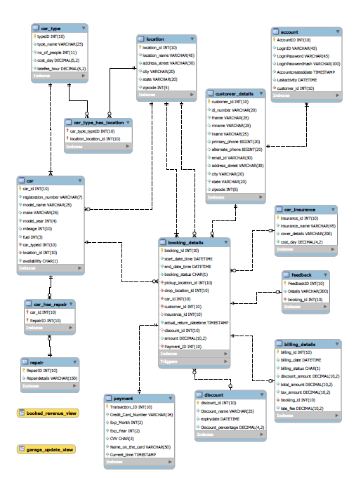

PL/SQL Statements:

Stored Procedures:

1. Calculate Late Fee and Tax:

Procedure Name: sp_calc_latefee_tax_amount

Given the return date and time while booking, actual return date and time, car id and booking amount, this procedure calculates the total late fee using late fee per hour, return date and time and the actual return date and time of the rental car. Once the total late fee is obtained, it is added to the amount and the total tax is calculated.

Creating Procedure:

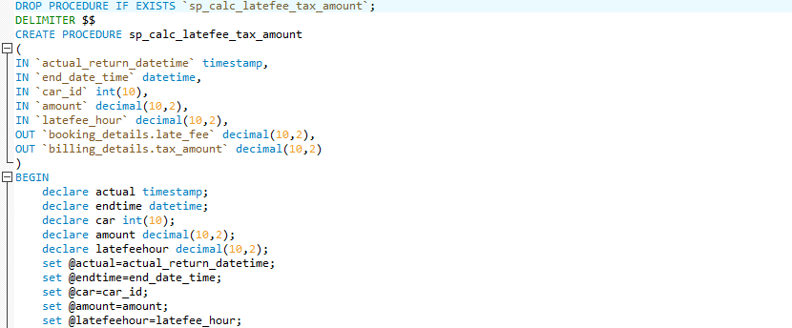

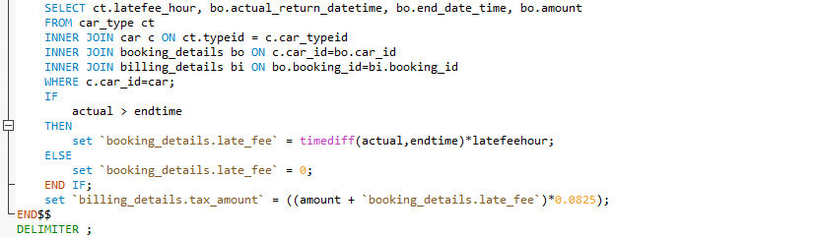

Calling the procedure:

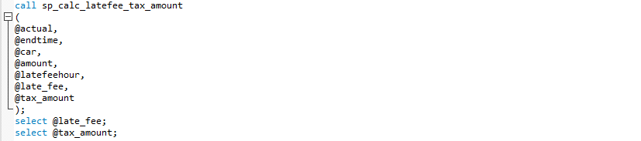

1. Calculate Discount Amount:

Procedure Name: sp_calc_discount_amount

Given the customer id, total amount and the discount code, this procedure calculates the discount amount based on the discount code used by the customer while booking the rental car. The discount amount is calculated on the total amount obtained after adding the late fee and the tax amount.

Creating procedure:

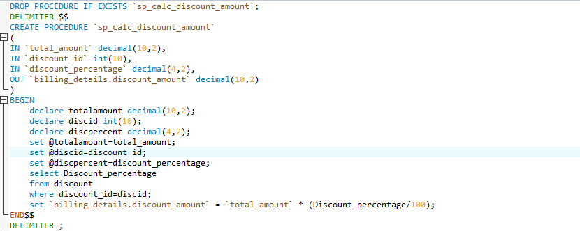

Calling the procedure:

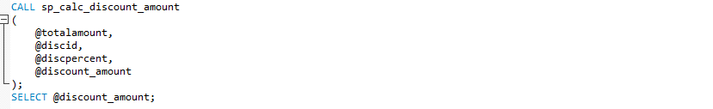

Triggers:

1. Generate Bill:

Trigger Name: generate_bill

This trigger inserts a tuple into the Billing_Details table when the actual return date is updated and booking status is updated to ‘R’ in Booking_Details table. It generates Bill when the rental car is returned. This is triggered whenever a row is updated in Booking_Details table.

Create Trigger:

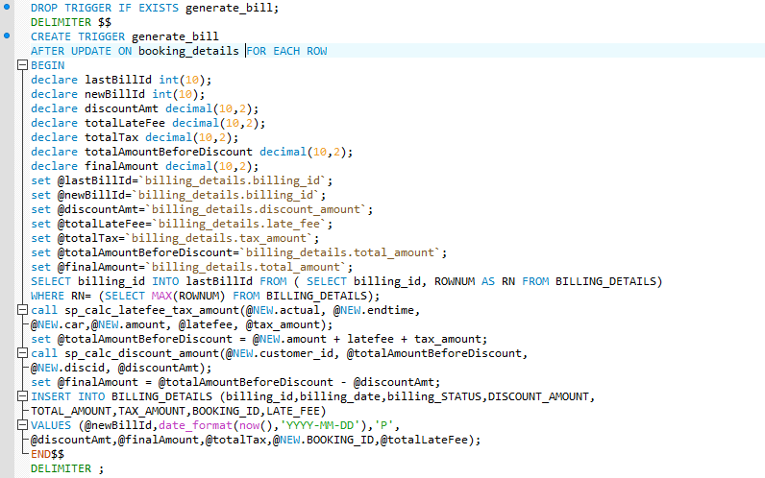

1. Update Car Details:

Trigger Name: car_details_update

This trigger updates the availability flag, mileage and location of the car in the car table when the actual return date is updated or when a booking is cancelled. This is triggered whenever a row is updated in Booking_Details table.

Create Trigger:

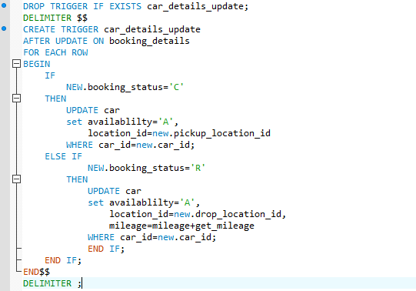

Views:

1. Getting Garage Update (Inventory):

View name: garage_update_view

This view helps the manager or any employee to get the details of the cars available for booking, which are not booked or not into the repair shop.

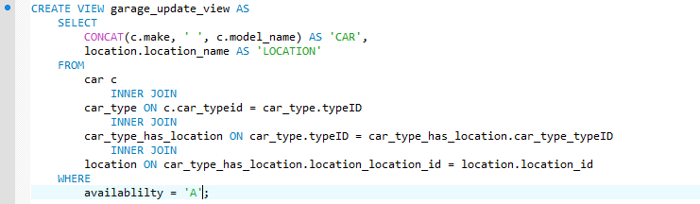

1. Revenue generated from booking(Turnover):

View name: booked_revenue_view

This view helps any employee or admin to get the revenue generated from the bookings. It gives the overall report of the cars, location, booking revenue easily.

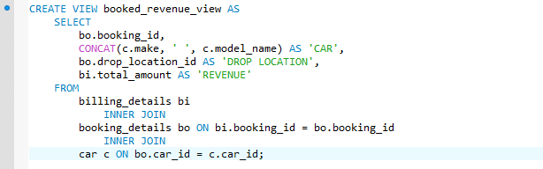

Users/Privileges:

1. The first user is the admin which can be used by the manager or any employee which gives the overall access of the database.
2. The second user is the customer which is given access of the three-major customer-oriented entities in the database. Customer won’t be having access to the details of the other customers or the bookings in the database.

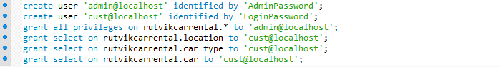

Conclusion:

During the course of this project, I learnt a lot of the work and best practices that go into creating a database, the rules to construct a good ER diagram, how to come up with relational schema mapping from the ER diagram, deriving the functional dependencies and how to normalize the relational schema. I learnt on how to design a system from Database perspective and how to efficiently store and manipulate data.

MY SQL DUMPS:

--MySQL dump 10.13 Distrib 5.7.17, for Win64 (x86_64)

--

-- Host: 127.0.0.1 Database: rutvikcarrental

-- ------------------------------------------------------

-- Server version 5.6.39

/*!40101 SET @OLD_CHARACTER_SET_CLIENT=@@CHARACTER_SET_CLIENT */;

/*!40101 SET @OLD_CHARACTER_SET_RESULTS=@@CHARACTER_SET_RESULTS */;

/*!40101 SET @OLD_COLLATION_CONNECTION=@@COLLATION_CONNECTION */;

/*!40101 SET NAMES utf8 */;

/*!40103 SET @OLD_TIME_ZONE=@@TIME_ZONE */;

/*!40103 SET TIME_ZONE='+00:00' */;

/*!40014 SET @OLD_UNIQUE_CHECKS=@@UNIQUE_CHECKS, UNIQUE_CHECKS=0 */;

/*!40014 SET @OLD_FOREIGN_KEY_CHECKS=@@FOREIGN_KEY_CHECKS, FOREIGN_KEY_CHECKS=0 */;

/*!40101 SET @OLD_SQL_MODE=@@SQL_MODE, SQL_MODE='NO_AUTO_VALUE_ON_ZERO' */;

/*!40111 SET @OLD_SQL_NOTES=@@SQL_NOTES, SQL_NOTES=0 */;

--

-- Table structure for table `account`

--

DROP TABLE IF EXISTS `account`;

/*!40101 SET @saved_cs_client = @@character_set_client */;

/*!40101 SET character_set_client = utf8 */;

CREATE TABLE `account` (

`AccountID` int(10) unsigned NOT NULL,

`LoginID` varchar(45) NOT NULL,

`LoginPassword` varchar(45) NOT NULL,

`LoginPasswordHash` varchar(100) NOT NULL,

`Accountcreateddate` timestamp NOT NULL DEFAULT CURRENT_TIMESTAMP ON UPDATE CURRENT_TIMESTAMP,

`Lastactivity` datetime NOT NULL,

`customer_id` int(10) unsigned NOT NULL,

PRIMARY KEY (`AccountID`),

UNIQUE KEY `AccountID_UNIQUE` (`AccountID`),

KEY `fk_Account_customer_details_idx` (`customer_id`),

CONSTRAINT `fk_Account_customer_details` FOREIGN KEY (`customer_id`) REFERENCES `customer_details` (`customer_id`) ON DELETE NO ACTION ON UPDATE NO ACTION

) ENGINE=InnoDB DEFAULT CHARSET=latin1;

/*!40101 SET character_set_client = @saved_cs_client */;

--

-- Dumping data for table `account`

--

LOCK TABLES `account` WRITE;

/*!40000 ALTER TABLE `account` DISABLE KEYS */;

INSERT INTO `account` VALUES (1001,'rutvikbryder','p@ssw0rd','a075d17f3d453073853f813838c15b8023b8c487038436354fe599c3942e1f95','2018-04-24 05:07:32','2018-04-24 01:07:32',50001),(1002,'rutvikbhopatrao','secretpassword','95d30169a59c418b52013315fc81bc99fdf0a7b03a116f346ab628496f349ed5','2018-04-26 05:07:32','2018-04-26 01:07:32',50001),(1004,'mitarana','ronaldoislife','a075d17f3d453073853f813838c15b8023b8c487038436354fe599c3942e1f95','2018-04-26 05:07:32','2018-04-26 01:07:32',50004),(1005,'mikeboy','callmemikeboy','95d30169a59c418b52013315fc81bc99fdf0a7b03a116f346ab628496f349ed5','2018-04-26 05:07:32','2018-04-26 01:07:32',50005),(1006,'sureshramesh','kitkatbreak','95d30169a59c418b52013315fc81bc99fdf0a7b03a116f346ab628496f349ed5','2018-04-26 05:07:32','2018-04-26 01:07:32',50007),(1007,'nivedhita','superwoman','a075d17f3d453073853f813838c15b8023b8c487038436354fe599c3942e1f95','2018-04-26 05:07:32','2018-04-26 01:07:32',50008),(1008,'marktowns','bemygyest','a075d17f3d453073853f813838c15b8023b8c487038436354fe599c3942e1f95','2018-04-26 05:07:32','2018-04-26 01:07:32',50009),(1009,'chrisalex','jaguar','a075d17f3d453073853f813838c15b8023b8c487038436354fe599c3942e1f95','2018-04-26 05:07:32','2018-04-26 01:07:32',50010),(1010,'markhuff','audibmw','95d30169a59c418b52013315fc81bc99fdf0a7b03a116f346ab628496f349ed5','2018-04-26 05:07:32','2018-04-26 01:07:32',50011),(1011,'danish','qwertyytrewq','95d30169a59c418b52013315fc81bc99fdf0a7b03a116f346ab628496f349ed5','2018-04-26 05:07:32','2018-04-26 01:07:32',50012),(1012,'markhufffff','aaacccbbbddd','a075d17f3d453073853f813838c15b8023b8c487038436354fe599c3942e1f95','2018-04-26 05:07:32','2018-04-26 01:07:32',50011),(1013,'velaronaldo','hbagdkhhgkj','a075d17f3d453073853f813838c15b8023b8c487038436354fe599c3942e1f95','2018-04-26 05:07:32','2018-04-26 01:07:32',50013),(1014,'naveenraj','secret','95d30169a59c418b52013315fc81bc99fdf0a7b03a116f346ab628496f349ed5','2018-04-26 05:07:32','2018-04-26 01:07:32',50006);

/*!40000 ALTER TABLE `account` ENABLE KEYS */;

UNLOCK TABLES;

--

-- Table structure for table `billing_details`

--

DROP TABLE IF EXISTS `billing_details`;

/*!40101 SET @saved_cs_client = @@character_set_client */;

/*!40101 SET character_set_client = utf8 */;

CREATE TABLE `billing_details` (

`billing_id` int(10) unsigned NOT NULL AUTO_INCREMENT,

`billing_date` datetime NOT NULL,

`billing_status` char(1) NOT NULL,

`discount_amount` decimal(10,2) unsigned NOT NULL,

`total_amount` decimal(10,2) unsigned NOT NULL,

`tax_amount` decimal(10,2) unsigned NOT NULL,

`booking_id` int(10) unsigned NOT NULL,

`late_fee` decimal(10,2) unsigned NOT NULL,

PRIMARY KEY (`billing_id`),

UNIQUE KEY `billing_id_UNIQUE` (`billing_id`),

KEY `billingfk_idx` (`booking_id`),

CONSTRAINT `billingfk` FOREIGN KEY (`booking_id`) REFERENCES `booking_details` (`booking_id`) ON DELETE NO ACTION ON UPDATE NO ACTION

) ENGINE=InnoDB AUTO_INCREMENT=1004 DEFAULT CHARSET=latin1;

/*!40101 SET character_set_client = @saved_cs_client */;

--

-- Dumping data for table `billing_details`

--

LOCK TABLES `billing_details` WRITE;

/*!40000 ALTER TABLE `billing_details` DISABLE KEYS */;

INSERT INTO `billing_details` VALUES (1001,'2018-01-25 00:00:00','P',24.36,138.03,12.38,100001,0.00),(1002,'2018-01-15 00:00:00','P',0.00,487.13,12.38,100003,0.00),(1003,'2018-04-04 00:00:00','P',10.39,41.57,3.96,100004,0.00);

/*!40000 ALTER TABLE `billing_details` ENABLE KEYS */;

UNLOCK TABLES;

--

-- Temporary view structure for view `booked_revenue_view`

--

DROP TABLE IF EXISTS `booked_revenue_view`;

/*!50001 DROP VIEW IF EXISTS `booked_revenue_view`*/;

SET @saved_cs_client = @@character_set_client;

SET character_set_client = utf8;

/*!50001 CREATE VIEW `booked_revenue_view` AS SELECT

1 AS `booking_id`,

1 AS `CAR`,

1 AS `DROP LOCATION`,

1 AS `REVENUE`*/;

SET character_set_client = @saved_cs_client;

--

-- Table structure for table `booking_details`

--

DROP TABLE IF EXISTS `booking_details`;

/*!40101 SET @saved_cs_client = @@character_set_client */;

/*!40101 SET character_set_client = utf8 */;

CREATE TABLE `booking_details` (

`booking_id` int(10) unsigned NOT NULL AUTO_INCREMENT,

`start_date_time` datetime NOT NULL,

`end_date_time` datetime NOT NULL,

`booking_status` char(1) NOT NULL,

`pickup_location_id` int(10) unsigned NOT NULL,

`drop_location_id` int(10) unsigned NOT NULL,

`car_id` int(10) unsigned NOT NULL,

`customer_id` int(10) unsigned NOT NULL,

`insurance_id` int(10) unsigned NOT NULL,

`actual_return_datetime` timestamp NOT NULL DEFAULT CURRENT_TIMESTAMP ON UPDATE CURRENT_TIMESTAMP,

`discount_id` int(10) unsigned NOT NULL,

`amount` decimal(10,2) unsigned DEFAULT NULL,

`Payment_ID` int(10) unsigned zerofill NOT NULL,

PRIMARY KEY (`booking_id`),

UNIQUE KEY `booking_id_UNIQUE` (`booking_id`),

KEY `pickup_locationfk_idx` (`pickup_location_id`),

KEY `drop_locationfk_idx` (`drop_location_id`),

KEY `carfk_idx` (`car_id`),

KEY `customerfk_idx` (`customer_id`),

KEY `car_insurancefk_idx` (`insurance_id`),

KEY `discountfk_idx` (`discount_id`),

KEY `fk_booking_details_Payment1_idx` (`Payment_ID`),

CONSTRAINT `car_insurancefk` FOREIGN KEY (`insurance_id`) REFERENCES `car_insurance` (`insurance_id`) ON DELETE NO ACTION ON UPDATE NO ACTION,

CONSTRAINT `carfk` FOREIGN KEY (`car_id`) REFERENCES `car` (`car_id`) ON DELETE NO ACTION ON UPDATE NO ACTION,

CONSTRAINT `customerfk` FOREIGN KEY (`customer_id`) REFERENCES `customer_details` (`customer_id`) ON DELETE NO ACTION ON UPDATE NO ACTION,

CONSTRAINT `discountfk` FOREIGN KEY (`discount_id`) REFERENCES `discount` (`discount_id`) ON DELETE NO ACTION ON UPDATE NO ACTION,

CONSTRAINT `drop_locationfk` FOREIGN KEY (`drop_location_id`) REFERENCES `location` (`location_id`) ON DELETE NO ACTION ON UPDATE NO ACTION,

CONSTRAINT `fk_booking_details_Payment1` FOREIGN KEY (`Payment_ID`) REFERENCES `payment` (`Transaction_ID`) ON DELETE NO ACTION ON UPDATE NO ACTION,

CONSTRAINT `pickup_locationfk` FOREIGN KEY (`pickup_location_id`) REFERENCES `location` (`location_id`) ON DELETE NO ACTION ON UPDATE NO ACTION

) ENGINE=InnoDB AUTO_INCREMENT=100009 DEFAULT CHARSET=latin1;

/*!40101 SET character_set_client = @saved_cs_client */;

--

-- Dumping data for table `booking_details`

--

LOCK TABLES `booking_details` WRITE;

/*!40000 ALTER TABLE `booking_details` DISABLE KEYS */;

INSERT INTO `booking_details` VALUES (100001,'2018-01-20 10:00:00','2018-01-25 10:00:00','R',101,101,1002,50006,2222,'2018-01-25 15:00:00',205,150.00,0000000001),(100002,'2018-01-21 11:00:00','2018-01-24 10:00:00','C',102,102,1032,50012,2222,'2018-04-26 21:29:44',222,90.00,0000000002),(100003,'2018-02-10 13:00:00','2018-01-15 13:00:00','R',101,101,1029,50011,2001,'2018-01-15 18:00:00',222,450.00,0000000003),(100004,'2018-04-24 13:00:00','2018-04-25 20:30:00','R',106,106,1048,50005,2002,'2018-04-24 00:30:00',202,48.00,0000000004),(100005,'2018-04-18 09:00:00','2018-04-25 09:00:00','B',102,106,1027,50010,2222,'2018-04-26 21:29:44',206,266.00,0000000005),(100006,'2018-04-21 17:00:00','2018-04-25 17:00:00','B',105,107,1014,50013,2003,'2018-04-26 21:29:44',202,168.00,0000000006),(100007,'2018-04-16 08:00:00','2018-04-25 17:00:00','B',102,102,1032,50009,2001,'2018-04-26 21:29:44',205,405.00,0000000007),(100008,'2018-04-11 08:00:00','2018-04-25 17:00:00','B',102,102,1013,50012,2001,'2018-04-26 21:29:44',205,630.00,0000000008);

/*!40000 ALTER TABLE `booking_details` ENABLE KEYS */;

UNLOCK TABLES;

/*!50003 SET @saved_cs_client = @@character_set_client */ ;

/*!50003 SET @saved_cs_results = @@character_set_results */ ;

/*!50003 SET @saved_col_connection = @@collation_connection */ ;

/*!50003 SET character_set_client = utf8mb4 */ ;

/*!50003 SET character_set_results = utf8mb4 */ ;

/*!50003 SET collation_connection = utf8mb4_general_ci */ ;

/*!50003 SET @saved_sql_mode = @@sql_mode */ ;

/*!50003 SET sql_mode = 'NO_ENGINE_SUBSTITUTION' */ ;

DELIMITER ;;

/*!50003 CREATE*/ /*!50017 DEFINER=`root`@`localhost`*/ /*!50003 TRIGGER car_details_update

AFTER UPDATE ON booking_details

FOR EACH ROW

BEGIN

IF

NEW.booking_status='C'

THEN

UPDATE car

set availablilty='A',

location_id=new.pickup_location_id

WHERE car_id=new.car_id;

ELSE IF

NEW.booking_status='R'

THEN

UPDATE car

set availablilty='A',

location_id=new.drop_location_id,

mileage=mileage+get_mileage

WHERE car_id=new.car_id;

END IF;

END IF;

END */;;

DELIMITER ;

/*!50003 SET sql_mode = @saved_sql_mode */ ;

/*!50003 SET character_set_client = @saved_cs_client */ ;

/*!50003 SET character_set_results = @saved_cs_results */ ;

/*!50003 SET collation_connection = @saved_col_connection */ ;

--

-- Table structure for table `car`

--

DROP TABLE IF EXISTS `car`;

/*!40101 SET @saved_cs_client = @@character_set_client */;

/*!40101 SET character_set_client = utf8 */;

CREATE TABLE `car` (

`car_id` int(10) unsigned NOT NULL AUTO_INCREMENT,

`registration_number` varchar(7) NOT NULL,

`model_name` varchar(25) NOT NULL,

`make` varchar(25) NOT NULL,

`model_year` int(4) unsigned NOT NULL,

`mileage` int(10) unsigned NOT NULL,

`fuel` int(3) NOT NULL,

`car_typeid` int(10) unsigned NOT NULL,

`location_id` int(10) unsigned NOT NULL,

`availablilty` char(1) NOT NULL,

PRIMARY KEY (`car_id`),

UNIQUE KEY `car_id_UNIQUE` (`car_id`),

KEY `cartypeidfk_idx` (`car_typeid`),

KEY `fk_car_location1_idx` (`location_id`),

CONSTRAINT `cartypeidfk` FOREIGN KEY (`car_typeid`) REFERENCES `car_type` (`typeID`) ON DELETE NO ACTION ON UPDATE NO ACTION,

CONSTRAINT `fk_car_location1` FOREIGN KEY (`location_id`) REFERENCES `location` (`location_id`) ON DELETE NO ACTION ON UPDATE NO ACTION

) ENGINE=InnoDB AUTO_INCREMENT=1052 DEFAULT CHARSET=latin1;

/*!40101 SET character_set_client = @saved_cs_client */;

--

-- Dumping data for table `car`

--

LOCK TABLES `car` WRITE;

/*!40000 ALTER TABLE `car` DISABLE KEYS */;

INSERT INTO `car` VALUES (1001,'RUTV1K','MUSTANG GT','FORD',2017,2400,70,16,103,'A'),(1002,'ABX1234','CIVIC','HONDA',2014,10000,100,11,101,'A'),(1003,'AHK7325','RAV4','TOYOTA',2016,3400,100,17,103,'A'),(1004,'ASD9090','ACCORD','HONDA',2016,200,100,13,103,'A'),(1005,'CFT1908','328I','BMW',2015,10800,100,16,104,'A'),(1006,'CXZ2356','AVENGER','DODGE',2015,5000,100,13,102,'A'),(1007,'EDM8610','GLA','MERCEDEZ BENZ',2015,12900,100,17,102,'A'),(1008,'EFB5427','WAYFARER','FORD',2014,14350,100,15,105,'A'),(1009,'FKD8202','GOLF','VOLKSWAGAN',2016,9000,100,12,106,'A'),(1010,'GLS7625','FOCUS','FORD',2014,12000,100,12,107,'A'),(1011,'GLZ2376','COROLLA','TOYOTA',2016,5000,100,11,104,'A'),(1012,'HGF5628','TAURUS','FORD',2013,15540,100,14,106,'A'),(1013,'HJK1234','CIVIC','HONDA',2015,20145,100,11,102,'N'),(1014,'HNX1890','PRIUS','TOYOTA',2015,15690,100,12,105,'N'),(1015,'JLS1097','SUBURBAN','CHEVROLET',2014,13290,100,19,104,'A'),(1016,'JSL7920','ODYSSEY','HONDA',2013,19320,100,20,106,'A'),(1017,'KJS1983','PRIUS','TOYOTA',2014,20900,100,12,104,'A'),(1018,'LDJ7719','EDGE','FORD',2016,5690,100,18,101,'A'),(1019,'LKJ7253','200','CHRYSTLER',2014,16300,100,14,107,'A'),(1020,'MKU0172','TLX','ACURA',2014,12345,100,16,103,'A'),(1021,'MNB8654','FALCON','FORD',2012,10900,100,15,103,'A'),(1022,'MWO9296','ODYSSEY','HONDA',2016,2300,100,20,103,'A'),(1023,'OHZ0976','EDGE','FORD',2012,27890,100,18,104,'A'),(1024,'OTY7293','CRUZE','CHEVROLET',2016,17800,100,13,102,'A'),(1025,'PAJ5289','GRAND CARAVAN','DODGE',2014,23478,100,20,105,'A'),(1026,'PLM9873','IMPALA','CHEVROLET',2015,18900,100,15,106,'A'),(1027,'POI7281','200','CHRYSTLER',2016,18830,100,14,102,'N'),(1028,'QIO7621','EQUINOX','CHEVROLET',2013,17560,100,17,107,'A'),(1029,'QSC8709','MKZ','LINCOLN',2012,18700,100,16,101,'A'),(1030,'QWE4562','LEGACY','SUBARU',2012,13420,100,13,101,'A'),(1031,'RKS9862','TAHOE','CHEVROLET',2013,20390,100,18,105,'A'),(1032,'SDF4567','FIESTA','FORD',2015,15000,100,11,102,'N'),(1033,'SDL9356','FOCUS','FORD',2016,10009,100,12,103,'A'),(1034,'SHK7767','QUEST','NISSAN',2012,23478,100,20,107,'A'),(1035,'TGB8961','GENESIS','HYUNDAI',2013,17620,100,16,102,'A'),(1036,'TRE9726','200','CHRYSTLER',2012,14320,100,14,105,'A'),(1037,'TSJ6290','QUEST','NISSAN',2015,13200,100,20,104,'A'),(1038,'UHJ6782','EXPEDITION','FORD',2015,11750,100,19,105,'A'),(1039,'UHV9786','IMPALA','CHEVROLET',2013,11500,100,15,104,'A'),(1040,'UIA8709','EXPEDITION','FORD',2012,19870,100,19,102,'A'),(1041,'UYT3981','LEGACY','SUBARU',2013,16750,100,13,104,'A'),(1042,'VBN6283','TAURUS','FORD',2015,17500,100,14,101,'A'),(1043,'WDV2458','FALCON','FORD',2016,5600,100,15,107,'A'),(1044,'WER3245','ACCENT','HYUNDAI',2014,12356,100,11,103,'A'),(1045,'WHM7619','AVALON','TOYOTA',2016,7800,100,16,105,'A'),(1046,'WIJ6190','EDGE','FORD',2014,18700,100,18,106,'A'),(1047,'WKJ7972','SEQUOIA','TOYOTA',2013,14500,100,19,103,'A'),(1048,'WLZ8955','ESCAPE','FORD',2012,19800,100,17,106,'A'),(1049,'XBM6822','SUBURBAN','CHEVROLET',2016,3400,100,19,106,'A'),(1050,'YSN1927','PATHFINDER','NISSAN',2014,14390,100,17,101,'A'),(1051,'ZDT8612','TAHOE','CHEVROLET',2015,14300,100,18,107,'A');

/*!40000 ALTER TABLE `car` ENABLE KEYS */;

UNLOCK TABLES;

--

-- Table structure for table `car_has_repair`

--

DROP TABLE IF EXISTS `car_has_repair`;

/*!40101 SET @saved_cs_client = @@character_set_client */;

/*!40101 SET character_set_client = utf8 */;

CREATE TABLE `car_has_repair` (

`car_id` int(10) unsigned NOT NULL,

`RepairID` int(10) unsigned NOT NULL,

PRIMARY KEY (`car_id`,`RepairID`),

KEY `fk_car_has_Car_Repair_Car_Repair1_idx` (`RepairID`),

KEY `fk_car_has_Car_Repair_car1_idx` (`car_id`),

CONSTRAINT `fk_car_has_Car_Repair_Car_Repair1` FOREIGN KEY (`RepairID`) REFERENCES `repair` (`RepairID`) ON DELETE NO ACTION ON UPDATE NO ACTION,

CONSTRAINT `fk_car_has_Car_Repair_car1` FOREIGN KEY (`car_id`) REFERENCES `car` (`car_id`) ON DELETE NO ACTION ON UPDATE NO ACTION

) ENGINE=InnoDB DEFAULT CHARSET=latin1;

/*!40101 SET character_set_client = @saved_cs_client */;

--

-- Dumping data for table `car_has_repair`

--

LOCK TABLES `car_has_repair` WRITE;

/*!40000 ALTER TABLE `car_has_repair` DISABLE KEYS */;

INSERT INTO `car_has_repair` VALUES (1002,301),(1003,301),(1006,301),(1005,303),(1006,305);

/*!40000 ALTER TABLE `car_has_repair` ENABLE KEYS */;

UNLOCK TABLES;

--

-- Table structure for table `car_insurance`

--

DROP TABLE IF EXISTS `car_insurance`;

/*!40101 SET @saved_cs_client = @@character_set_client */;

/*!40101 SET character_set_client = utf8 */;

CREATE TABLE `car_insurance` (

`insurance_id` int(10) unsigned NOT NULL AUTO_INCREMENT,

`insurance_name` varchar(45) NOT NULL,

`cover_details` varchar(200) NOT NULL,

`cost_day` decimal(4,2) NOT NULL,

PRIMARY KEY (`insurance_id`),

UNIQUE KEY `insurance_id_UNIQUE` (`insurance_id`)

) ENGINE=InnoDB AUTO_INCREMENT=2223 DEFAULT CHARSET=latin1;

/*!40101 SET character_set_client = @saved_cs_client */;

--

-- Dumping data for table `car_insurance`

--

LOCK TABLES `car_insurance` WRITE;

/*!40000 ALTER TABLE `car_insurance` DISABLE KEYS */;

INSERT INTO `car_insurance` VALUES (2001,'COLLISION DAMAGE WAIVER','Covers theft and total damage to the rental car',15.00),(2002,'SUPPLEMENTAL LIABILITY PROTECTION','Covers damage done to others',12.00),(2003,'PERSONAL ACCIDENT INSURANCE','Covers medical costs for driver and passengers',10.00),(2004,'PERSONAL EFFECTS COVERAGE','Covers theft of personal belongings',5.00),(2222,'NO INSURANCE TAKEN ','Covers nothing',0.00);

/*!40000 ALTER TABLE `car_insurance` ENABLE KEYS */;

UNLOCK TABLES;

--

-- Table structure for table `car_type`

--

DROP TABLE IF EXISTS `car_type`;

/*!40101 SET @saved_cs_client = @@character_set_client */;

/*!40101 SET character_set_client = utf8 */;

CREATE TABLE `car_type` (

`typeID` int(10) unsigned NOT NULL AUTO_INCREMENT,

`type_name` varchar(25) NOT NULL,

`no_of_people` int(11) NOT NULL,

`cost_day` decimal(5,2) NOT NULL,

`latefee_hour` decimal(5,2) NOT NULL,

PRIMARY KEY (`typeID`),

UNIQUE KEY `typeID_UNIQUE` (`typeID`)

) ENGINE=InnoDB AUTO_INCREMENT=21 DEFAULT CHARSET=latin1;

/*!40101 SET character_set_client = @saved_cs_client */;

--

-- Dumping data for table `car_type`

--

LOCK TABLES `car_type` WRITE;

/*!40000 ALTER TABLE `car_type` DISABLE KEYS */;

INSERT INTO `car_type` VALUES (11,'ECONOMY',5,30.00,0.90),(12,'COMPACT',5,32.00,0.96),(13,'MID SIZE',5,35.00,1.05),(14,'STANDARD',5,38.00,1.14),(15,'FULL SIZE',5,40.00,1.20),(16,'LUXURY CAR',5,75.00,2.25),(17,'MID SIZE SUV',5,36.00,1.08),(18,'STANDARD SUV',5,40.00,1.20),(19,'FULL SIZE SUV',8,60.00,1.80),(20,'MINI VAN',7,70.00,2.10);

/*!40000 ALTER TABLE `car_type` ENABLE KEYS */;

UNLOCK TABLES;

--

-- Table structure for table `car_type_has_location`

--

DROP TABLE IF EXISTS `car_type_has_location`;

/*!40101 SET @saved_cs_client = @@character_set_client */;

/*!40101 SET character_set_client = utf8 */;

CREATE TABLE `car_type_has_location` (

`car_type_typeID` int(10) unsigned NOT NULL,

`location_location_id` int(10) unsigned NOT NULL,

PRIMARY KEY (`car_type_typeID`,`location_location_id`),

KEY `fk_car_type_has_location_location1_idx` (`location_location_id`),

KEY `fk_car_type_has_location_car_type1_idx` (`car_type_typeID`),

CONSTRAINT `fk_car_type_has_location_car_type1` FOREIGN KEY (`car_type_typeID`) REFERENCES `car_type` (`typeID`) ON DELETE NO ACTION ON UPDATE NO ACTION,

CONSTRAINT `fk_car_type_has_location_location1` FOREIGN KEY (`location_location_id`) REFERENCES `location` (`location_id`) ON DELETE NO ACTION ON UPDATE NO ACTION

) ENGINE=InnoDB DEFAULT CHARSET=latin1;

/*!40101 SET character_set_client = @saved_cs_client */;

--

-- Dumping data for table `car_type_has_location`

--

LOCK TABLES `car_type_has_location` WRITE;

/*!40000 ALTER TABLE `car_type_has_location` DISABLE KEYS */;

INSERT INTO `car_type_has_location` VALUES (11,101),(12,101),(13,101),(15,101),(16,101),(17,101),(19,101),(20,101),(11,102),(12,102),(13,102),(14,102),(15,102),(17,102),(18,102),(11,103),(13,103),(14,103),(17,103),(18,103),(11,104),(15,104),(17,104),(11,105),(14,105),(15,105),(16,105),(17,105),(18,105),(19,105),(20,105),(14,106),(16,106),(19,106),(12,107),(13,107),(17,107);

/*!40000 ALTER TABLE `car_type_has_location` ENABLE KEYS */;

UNLOCK TABLES;

--

-- Table structure for table `customer_details`

--

DROP TABLE IF EXISTS `customer_details`;

/*!40101 SET @saved_cs_client = @@character_set_client */;

/*!40101 SET character_set_client = utf8 */;

CREATE TABLE `customer_details` (

`customer_id` int(10) unsigned NOT NULL AUTO_INCREMENT,

`dl_number` varchar(20) NOT NULL,

`fname` varchar(25) NOT NULL,

`mname` varchar(25) DEFAULT NULL,

`lname` varchar(25) NOT NULL,

`primary_phone` bigint(20) unsigned NOT NULL,

`alternate_phone` bigint(20) unsigned DEFAULT NULL,

`email_id` varchar(30) NOT NULL,

`address_street` varchar(30) NOT NULL,

`city` varchar(20) NOT NULL,

`state` varchar(20) NOT NULL,

`zipcode` int(5) unsigned zerofill NOT NULL,

PRIMARY KEY (`customer_id`),

UNIQUE KEY `serial_number_UNIQUE` (`customer_id`)

) ENGINE=InnoDB AUTO_INCREMENT=50014 DEFAULT CHARSET=latin1;

/*!40101 SET character_set_client = @saved_cs_client */;

--

-- Dumping data for table `customer_details`

--

LOCK TABLES `customer_details` WRITE;

/*!40000 ALTER TABLE `customer_details` DISABLE KEYS */;

INSERT INTO `customer_details` VALUES (50001,'MH4620110009106','Rutvik','Rajendra','Bhopatrao',8573341217,9665407666,'rutvikbhopatrao@gmail.com','1185 Boylston St','Boston','MA',02215),(50002,'MH0920131112548','Aditya','Rajendra','Patil',8573341125,9604344455,'adityayadravkar@gmail.com','1185 Boylston St ','Boston','MA',02215),(50003,'KN0120121257777','Prajwal','Renuka','Praveen',9990009990,7897734377,'prajwalpraveen@gmail.com','235 Heath St','Boston','MA',02113),(50004,'E7521097','MITA','','RANA',8798796788,8573341111,'mitarana@gmail.com','367 MEANDERING WAY','HOUSTON','TEXAS',76245),(50005,'F0091266','MIKE','','BOYEAR',4554674668,8573341112,'mikeboy@gmail.com','1007 DALLAS PARKWAY','DALLAS','TEXAS',72212),(50006,'F1234554','NAVEEN','','RAJ',7879779888,8573341113,'naveen@gmail.com','700 CAMPBELL RD','RICHARDSON','TEXAS',75080),(50007,'F2345611','SURESH','KUMAR','GOPALAKRISHNAN',4334677661,8573341114,'suresh2234@gmail.com','6547 CANOGA AVE','CANOGA PARK','CALIFORNIA',91303),(50008,'F9764521','NIVEDITHA','','VARADHA CHANDRASEKARAN',2477644646,8573341115,'nivi07@gmail.com','800 RENNER RD','RICHARDSON','TEXAS',75080),(50009,'I3478953','MARK','S','TOWNSEND',6797976767,8573341116,'markstown@gmail.com','7825 MCCALLUM BLVD','DALLAS','TEXAS',75252),(50010,'P1234567','CHRIS','','ALEXANDER',9874323787,8573341117,'chrisalex@gmail.com','2256 WALL STREET','NEWARK','NEW JERSEY',65289),(50011,'R8763578','MARK','','HUFF',7687923467,8573341118,'markhuff@gmail.com','1445 ROSS AVE','DALLAS','TEXAS',75202),(50012,'T0981237','DANISH','','HASSAN',7876437776,8573341119,'danishhasan@gmail.com','888 PRESTON ROAD','DULLES','VIRGINIA',92367),(50013,'V5690245','VELA','R','REYNALDO',8797455555,8573341120,'reyvela@gmail.com','0099 ALMA ROAD','DULLES','VIRGINIA',97325);

/*!40000 ALTER TABLE `customer_details` ENABLE KEYS */;

UNLOCK TABLES;

--

-- Table structure for table `discount`

--

DROP TABLE IF EXISTS `discount`;

/*!40101 SET @saved_cs_client = @@character_set_client */;

/*!40101 SET character_set_client = utf8 */;

CREATE TABLE `discount` (

`discount_id` int(10) unsigned NOT NULL AUTO_INCREMENT,

`Discount_name` varchar(25) NOT NULL,

`expirydate` datetime NOT NULL,

`Discount_percentage` decimal(4,2) NOT NULL,

PRIMARY KEY (`discount_id`),

UNIQUE KEY `discount_id_UNIQUE` (`discount_id`)

) ENGINE=InnoDB AUTO_INCREMENT=223 DEFAULT CHARSET=latin1;

/*!40101 SET character_set_client = @saved_cs_client */;

--

-- Dumping data for table `discount`

--

LOCK TABLES `discount` WRITE;

/*!40000 ALTER TABLE `discount` DISABLE KEYS */;

INSERT INTO `discount` VALUES (201,'WEEKLY RENTALS','2018-01-25 00:00:00',25.00),(202,'CTS CORPORATE','2019-09-02 00:00:00',20.00),(203,'UPGRADE SPECIAL','2017-10-29 00:00:00',20.00),(204,'IBM CORPORATE','2020-11-09 00:00:00',25.00),(205,'HOLIDAY SPECIAL','2016-12-15 00:00:00',10.00),(206,'ONE WAY SPECIAL','2018-02-18 00:00:00',20.00),(222,'NO DISCOUNTAPPLIED','2050-01-01 00:00:00',0.00);

/*!40000 ALTER TABLE `discount` ENABLE KEYS */;

UNLOCK TABLES;

--

-- Table structure for table `feedback`

--

DROP TABLE IF EXISTS `feedback`;

/*!40101 SET @saved_cs_client = @@character_set_client */;

/*!40101 SET character_set_client = utf8 */;

CREATE TABLE `feedback` (

`FeedbackID` int(10) unsigned NOT NULL AUTO_INCREMENT,

`Details` varchar(300) NOT NULL,

`booking_id` int(10) unsigned NOT NULL,

PRIMARY KEY (`FeedbackID`),

UNIQUE KEY `FeedbackID_UNIQUE` (`FeedbackID`),

KEY `fk_Feedback_booking_details1_idx` (`booking_id`),

CONSTRAINT `fk_Feedback_booking_details1` FOREIGN KEY (`booking_id`) REFERENCES `booking_details` (`booking_id`) ON DELETE NO ACTION ON UPDATE NO ACTION

) ENGINE=InnoDB AUTO_INCREMENT=6 DEFAULT CHARSET=latin1;

/*!40101 SET character_set_client = @saved_cs_client */;

--

-- Dumping data for table `feedback`

--

LOCK TABLES `feedback` WRITE;

/*!40000 ALTER TABLE `feedback` DISABLE KEYS */;

INSERT INTO `feedback` VALUES (1,'We travel at minimum 6 times per year and always use a rental car. Chose and even joined their customer program because of their supposed reputable name. Ended up almost 5 times as much as quoted price. Cancelled membership and will never rent from them again. I understand actual cost usually is hig',100001),(2,'I had an unfortunate car accident that literally left me stranded, so I reached out to Enterprise. I went to the closest location (McDowell St, Raleigh, NC) to work Friday via nice co-worker & Jordan greeted me with a smile. He was very kind and so helpful. Today, I was able to claim vs out of pocke',100002),(3,'My local Enterprise Car rental place is the best! Hoover, AL on Columbiana Rd. I rent fairly often, and just about every person at this branch from trainees up to manager is courteous, knowledgeable and super efficient at getting me checked in and out without any hassle. Recently, I even obtained a ',100003),(4,'I have been using the Services from Enterprise rental car from the past 10 months and I have rented the car for around 200 days during this period and from different locations in United States Orange county. I would recommend anyone coming into the country and looking for rental car, I would say thi',100005),(5,'Service was excellent but very expensive compared to other companies. My car was dirty but I agreed to take it that way without being washed. Only had 1/4 tank of fuel to start. Discounts were applied but still pricey for a week\'s time.',100007);

/*!40000 ALTER TABLE `feedback` ENABLE KEYS */;

UNLOCK TABLES;

--

-- Temporary view structure for view `garage_update_view`

--

DROP TABLE IF EXISTS `garage_update_view`;

/*!50001 DROP VIEW IF EXISTS `garage_update_view`*/;

SET @saved_cs_client = @@character_set_client;

SET character_set_client = utf8;

/*!50001 CREATE VIEW `garage_update_view` AS SELECT

1 AS `CAR`,

1 AS `LOCATION`*/;

SET character_set_client = @saved_cs_client;

--

-- Table structure for table `location`

--

DROP TABLE IF EXISTS `location`;

/*!40101 SET @saved_cs_client = @@character_set_client */;

/*!40101 SET character_set_client = utf8 */;

CREATE TABLE `location` (

`location_id` int(10) unsigned NOT NULL AUTO_INCREMENT,

`location_name` varchar(45) NOT NULL,

`address_street` varchar(30) NOT NULL,

`city` varchar(20) NOT NULL,

`state` varchar(20) NOT NULL,

`zipcode` int(5) unsigned NOT NULL,

PRIMARY KEY (`location_id`)

) ENGINE=InnoDB AUTO_INCREMENT=108 DEFAULT CHARSET=latin1;

/*!40101 SET character_set_client = @saved_cs_client */;

--

-- Dumping data for table `location`

--

LOCK TABLES `location` WRITE;

/*!40000 ALTER TABLE `location` DISABLE KEYS */;

INSERT INTO `location` VALUES (101,'DALLAS LOVE FIELD AIRPORT','89 Herb Kelleher Way','Dallas','Texas',75235),(102,'LOS ANGELES INTL AIRPORT','154 World Way','Los Angeles','California',90045),(103,'BOSTON LOGAN INTL AIRPORT','15 Transportation Way','Boston','Massachusetts',75261),(104,'WEST HOUSTON AIRPORT','5400 Groschke Rd','Houston','Texas',77094),(105,'WASHINGTON DULLES INTL AIRPORT','78 Saarinen Cir','Dulles','Virginia',20166),(106,'NEWARK LIBERTY INTL AIRPORT','120 Brewster Rd','Newark','New Jersey',7114),(107,'SALT LAKE CITY INTL AIRPORT','6 N Terminal Dr','Salt Lake City','Utah',84122);

/*!40000 ALTER TABLE `location` ENABLE KEYS */;

UNLOCK TABLES;

--

-- Table structure for table `payment`

--

DROP TABLE IF EXISTS `payment`;

/*!40101 SET @saved_cs_client = @@character_set_client */;

/*!40101 SET character_set_client = utf8 */;

CREATE TABLE `payment` (

`Transaction_ID` int(10) unsigned zerofill NOT NULL AUTO_INCREMENT,

`Credit_Card_Number` varchar(16) NOT NULL,

`Exp_Month` int(2) NOT NULL,

`Exp_Year` int(2) NOT NULL,

`CVV` char(3) NOT NULL,

`Name_on_the_card` varchar(50) NOT NULL,

`Current_time` timestamp NOT NULL DEFAULT CURRENT_TIMESTAMP ON UPDATE CURRENT_TIMESTAMP,

PRIMARY KEY (`Transaction_ID`),

UNIQUE KEY `Credit_Card_ID_UNIQUE` (`Transaction_ID`)

) ENGINE=InnoDB AUTO_INCREMENT=9 DEFAULT CHARSET=latin1;

/*!40101 SET character_set_client = @saved_cs_client */;

--

-- Dumping data for table `payment`

--

LOCK TABLES `payment` WRITE;

/*!40000 ALTER TABLE `payment` DISABLE KEYS */;

INSERT INTO `payment` VALUES (0000000001,'9876789976544663',12,23,'225','NAVEEN RAJ','2016-04-26 15:10:54'),(0000000002,'6687676676676564',8,22,'789','DANISH HASSAN','2016-04-28 15:10:54'),(0000000003,'9876789976544456',6,20,'020','MARK HUIFF','2016-04-29 15:20:54'),(0000000004,'9876787987876688',8,18,'114','MIKE B','2016-04-29 15:40:54'),(0000000005,'9876789987978978',8,17,'123','CHRIS ALEXANDER','2016-04-30 16:10:54'),(0000000006,'7879987867645657',9,25,'258','VELA R','2016-05-01 05:12:54'),(0000000007,'7899764545786444',1,22,'456','MARK S T','2016-05-02 05:12:54'),(0000000008,'7946121687434346',12,21,'254','DANISH HASSAN','2016-05-02 15:51:54');

/*!40000 ALTER TABLE `payment` ENABLE KEYS */;

UNLOCK TABLES;

--

-- Table structure for table `repair`

--

DROP TABLE IF EXISTS `repair`;

/*!40101 SET @saved_cs_client = @@character_set_client */;

/*!40101 SET character_set_client = utf8 */;

CREATE TABLE `repair` (

`RepairID` int(10) unsigned NOT NULL AUTO_INCREMENT,

`Repairdetails` varchar(150) NOT NULL,

PRIMARY KEY (`RepairID`),

UNIQUE KEY `RepairID_UNIQUE` (`RepairID`)

) ENGINE=InnoDB AUTO_INCREMENT=307 DEFAULT CHARSET=latin1;

/*!40101 SET character_set_client = @saved_cs_client */;

--

-- Dumping data for table `repair`

--

LOCK TABLES `repair` WRITE;

/*!40000 ALTER TABLE `repair` DISABLE KEYS */;

INSERT INTO `repair` VALUES (301,'Wheels change'),(302,'radiator damage'),(303,'Airconditioner failure'),(304,'Door jams'),(305,'Engine check light'),(306,'Taillight failure');

/*!40000 ALTER TABLE `repair` ENABLE KEYS */;

UNLOCK TABLES;

--

-- Dumping events for database 'rutvikcarrental'

--

--

-- Dumping routines for database 'rutvikcarrental'

--

/*!50003 DROP PROCEDURE IF EXISTS `sp_calc_discount_amount` */;

/*!50003 SET @saved_cs_client = @@character_set_client */ ;

/*!50003 SET @saved_cs_results = @@character_set_results */ ;

/*!50003 SET @saved_col_connection = @@collation_connection */ ;

/*!50003 SET character_set_client = utf8mb4 */ ;

/*!50003 SET character_set_results = utf8mb4 */ ;

/*!50003 SET collation_connection = utf8mb4_general_ci */ ;

/*!50003 SET @saved_sql_mode = @@sql_mode */ ;

/*!50003 SET sql_mode = 'NO_ENGINE_SUBSTITUTION' */ ;

DELIMITER ;;

CREATE DEFINER=`root`@`localhost` PROCEDURE `sp_calc_discount_amount`(

IN `total_amount` decimal(10,2),

IN `discount_id` int(10),

IN `discount_percentage` decimal(4,2),

OUT `billing_details.discount_amount` decimal(10,2)

)

BEGIN

declare totalamount decimal(10,2);

declare discid int(10);

declare discpercent decimal(4,2);

set @totalamount=total_amount;

set @discid=discount_id;

set @discpercent=discount_percentage;

select Discount_percentage

from discount

where discount_id=discid;

set `billing_details.discount_amount` = `total_amount` * (Discount_percentage/100);

END ;;

DELIMITER ;

/*!50003 SET sql_mode = @saved_sql_mode */ ;

/*!50003 SET character_set_client = @saved_cs_client */ ;

/*!50003 SET character_set_results = @saved_cs_results */ ;

/*!50003 SET collation_connection = @saved_col_connection */ ;

/*!50003 DROP PROCEDURE IF EXISTS `sp_calc_latefee_tax_amount` */;

/*!50003 SET @saved_cs_client = @@character_set_client */ ;

/*!50003 SET @saved_cs_results = @@character_set_results */ ;

/*!50003 SET @saved_col_connection = @@collation_connection */ ;

/*!50003 SET character_set_client = utf8mb4 */ ;

/*!50003 SET character_set_results = utf8mb4 */ ;

/*!50003 SET collation_connection = utf8mb4_general_ci */ ;

/*!50003 SET @saved_sql_mode = @@sql_mode */ ;

/*!50003 SET sql_mode = 'NO_ENGINE_SUBSTITUTION' */ ;

DELIMITER ;;

CREATE DEFINER=`root`@`localhost` PROCEDURE `sp_calc_latefee_tax_amount`(

IN `actual_return_datetime` timestamp,

IN `end_date_time` datetime,

IN `car_id` int(10),

IN `amount` decimal(10,2),

IN `latefee_hour` decimal(10,2),

OUT `booking_details.late_fee` decimal(10,2),

OUT `billing_details.tax_amount` decimal(10,2)

)

BEGIN

declare actual timestamp;

declare endtime datetime;

declare car int(10);

declare amount decimal(10,2);

declare latefeehour decimal(10,2);

set @actual=actual_return_datetime;

set @endtime=end_date_time;

set @car=car_id;

set @amount=amount;

set @latefeehour=latefee_hour;

SELECT ct.latefee_hour, bo.actual_return_datetime, bo.end_date_time, bo.amount

FROM car_type ct

INNER JOIN car c ON ct.typeid = c.car_typeid

INNER JOIN booking_details bo ON c.car_id=bo.car_id

INNER JOIN billing_details bi ON bo.booking_id=bi.booking_id

WHERE c.car_id=car;

IF

actual > endtime

THEN

set `booking_details.late_fee` = timediff(actual,endtime)*latefeehour;

ELSE

set `booking_details.late_fee` = 0;

END IF;

set `billing_details.tax_amount` = ((amount + `booking_details.late_fee`)*0.0825);

END ;;

DELIMITER ;

/*!50003 SET sql_mode = @saved_sql_mode */ ;

/*!50003 SET character_set_client = @saved_cs_client */ ;

/*!50003 SET character_set_results = @saved_cs_results */ ;

/*!50003 SET collation_connection = @saved_col_connection */ ;

--

-- Final view structure for view `booked_revenue_view`

--

/*!50001 DROP VIEW IF EXISTS `booked_revenue_view`*/;

/*!50001 SET @saved_cs_client = @@character_set_client */;

/*!50001 SET @saved_cs_results = @@character_set_results */;

/*!50001 SET @saved_col_connection = @@collation_connection */;

/*!50001 SET character_set_client = utf8mb4 */;

/*!50001 SET character_set_results = utf8mb4 */;

/*!50001 SET collation_connection = utf8mb4_general_ci */;

/*!50001 CREATE ALGORITHM=UNDEFINED */

/*!50013 DEFINER=`root`@`localhost` SQL SECURITY DEFINER */

/*!50001 VIEW `booked_revenue_view` AS select `bo`.`booking_id` AS `booking_id`,concat(`c`.`make`,' ',`c`.`model_name`) AS `CAR`,`bo`.`drop_location_id` AS `DROP LOCATION`,`bi`.`total_amount` AS `REVENUE` from ((`billing_details` `bi` join `booking_details` `bo` on((`bi`.`booking_id` = `bo`.`booking_id`))) join `car` `c` on((`bo`.`car_id` = `c`.`car_id`))) */;

/*!50001 SET character_set_client = @saved_cs_client */;

/*!50001 SET character_set_results = @saved_cs_results */;

/*!50001 SET collation_connection = @saved_col_connection */;

--

-- Final view structure for view `garage_update_view`

--

/*!50001 DROP VIEW IF EXISTS `garage_update_view`*/;

/*!50001 SET @saved_cs_client = @@character_set_client */;

/*!50001 SET @saved_cs_results = @@character_set_results */;

/*!50001 SET @saved_col_connection = @@collation_connection */;

/*!50001 SET character_set_client = utf8mb4 */;

/*!50001 SET character_set_results = utf8mb4 */;

/*!50001 SET collation_connection = utf8mb4_general_ci */;

/*!50001 CREATE ALGORITHM=UNDEFINED */

/*!50013 DEFINER=`root`@`localhost` SQL SECURITY DEFINER */

/*!50001 VIEW `garage_update_view` AS select concat(`c`.`make`,' ',`c`.`model_name`) AS `CAR`,`location`.`location_name` AS `LOCATION` from (((`car` `c` join `car_type` on((`c`.`car_typeid` = `car_type`.`typeID`))) join `car_type_has_location` on((`car_type`.`typeID` = `car_type_has_location`.`car_type_typeID`))) join `location` on((`car_type_has_location`.`location_location_id` = `location`.`location_id`))) where (`c`.`availablilty` = 'A') */;

/*!50001 SET character_set_client = @saved_cs_client */;

/*!50001 SET character_set_results = @saved_cs_results */;

/*!50001 SET collation_connection = @saved_col_connection */;

/*!40103 SET TIME_ZONE=@OLD_TIME_ZONE */;

/*!40101 SET SQL_MODE=@OLD_SQL_MODE */;

/*!40014 SET FOREIGN_KEY_CHECKS=@OLD_FOREIGN_KEY_CHECKS */;

/*!40014 SET UNIQUE_CHECKS=@OLD_UNIQUE_CHECKS */;

/*!40101 SET CHARACTER_SET_CLIENT=@OLD_CHARACTER_SET_CLIENT */;

/*!40101 SET CHARACTER_SET_RESULTS=@OLD_CHARACTER_SET_RESULTS */;

/*!40101 SET COLLATION_CONNECTION=@OLD_COLLATION_CONNECTION */;

/*!40111 SET SQL_NOTES=@OLD_SQL_NOTES */;

-- Dump completed on 2018-04-27 12:05:59